

Dear [NAME]:

Did you know that the American Cancer Society reports that 1 in 2 men and 1 in 3 women will likely develop cancer in their lifetime? Thanks to advancements in treatment, more people are beating their cancer and need help with the after effects.

On June 1st & 2nd, I’m participating in the 18th Annual 24 Hours in the Canyon bike event. This event funds an adult Cancer Survivorship Center (www.24survivorship.org) that is FREE for patients to access, regardless of where they were treated, and from the moment of their diagnosis. This center is truly a one-of-a-kind. Patients can visit with an oncology nurse about their treatments and learn what to watch for in terms of side effects. Survivors also can take advantage of the many Health & Wellness classes/events, nutrition & emotional counseling, as well as a class that helps combat “chemo brain”. All of this is provided for FREE thanks to this event!

My goal is to fundraise $[AMOUNT] to help provide these services at the Survivorship Center. I am asking you to make a tax-deductible donation so that cancer survivors will continue to get the care they need at no charge to them.

Enclosed you’ll find a donation form. If you feel led to help with my efforts, please fill it out & return it to the address listed. Also, please be sure to put my name in the blank asking for the name of the rider you are supporting. THANK YOU for helping me in my fundraising efforts, but more importantly, for helping survivors like Jack.

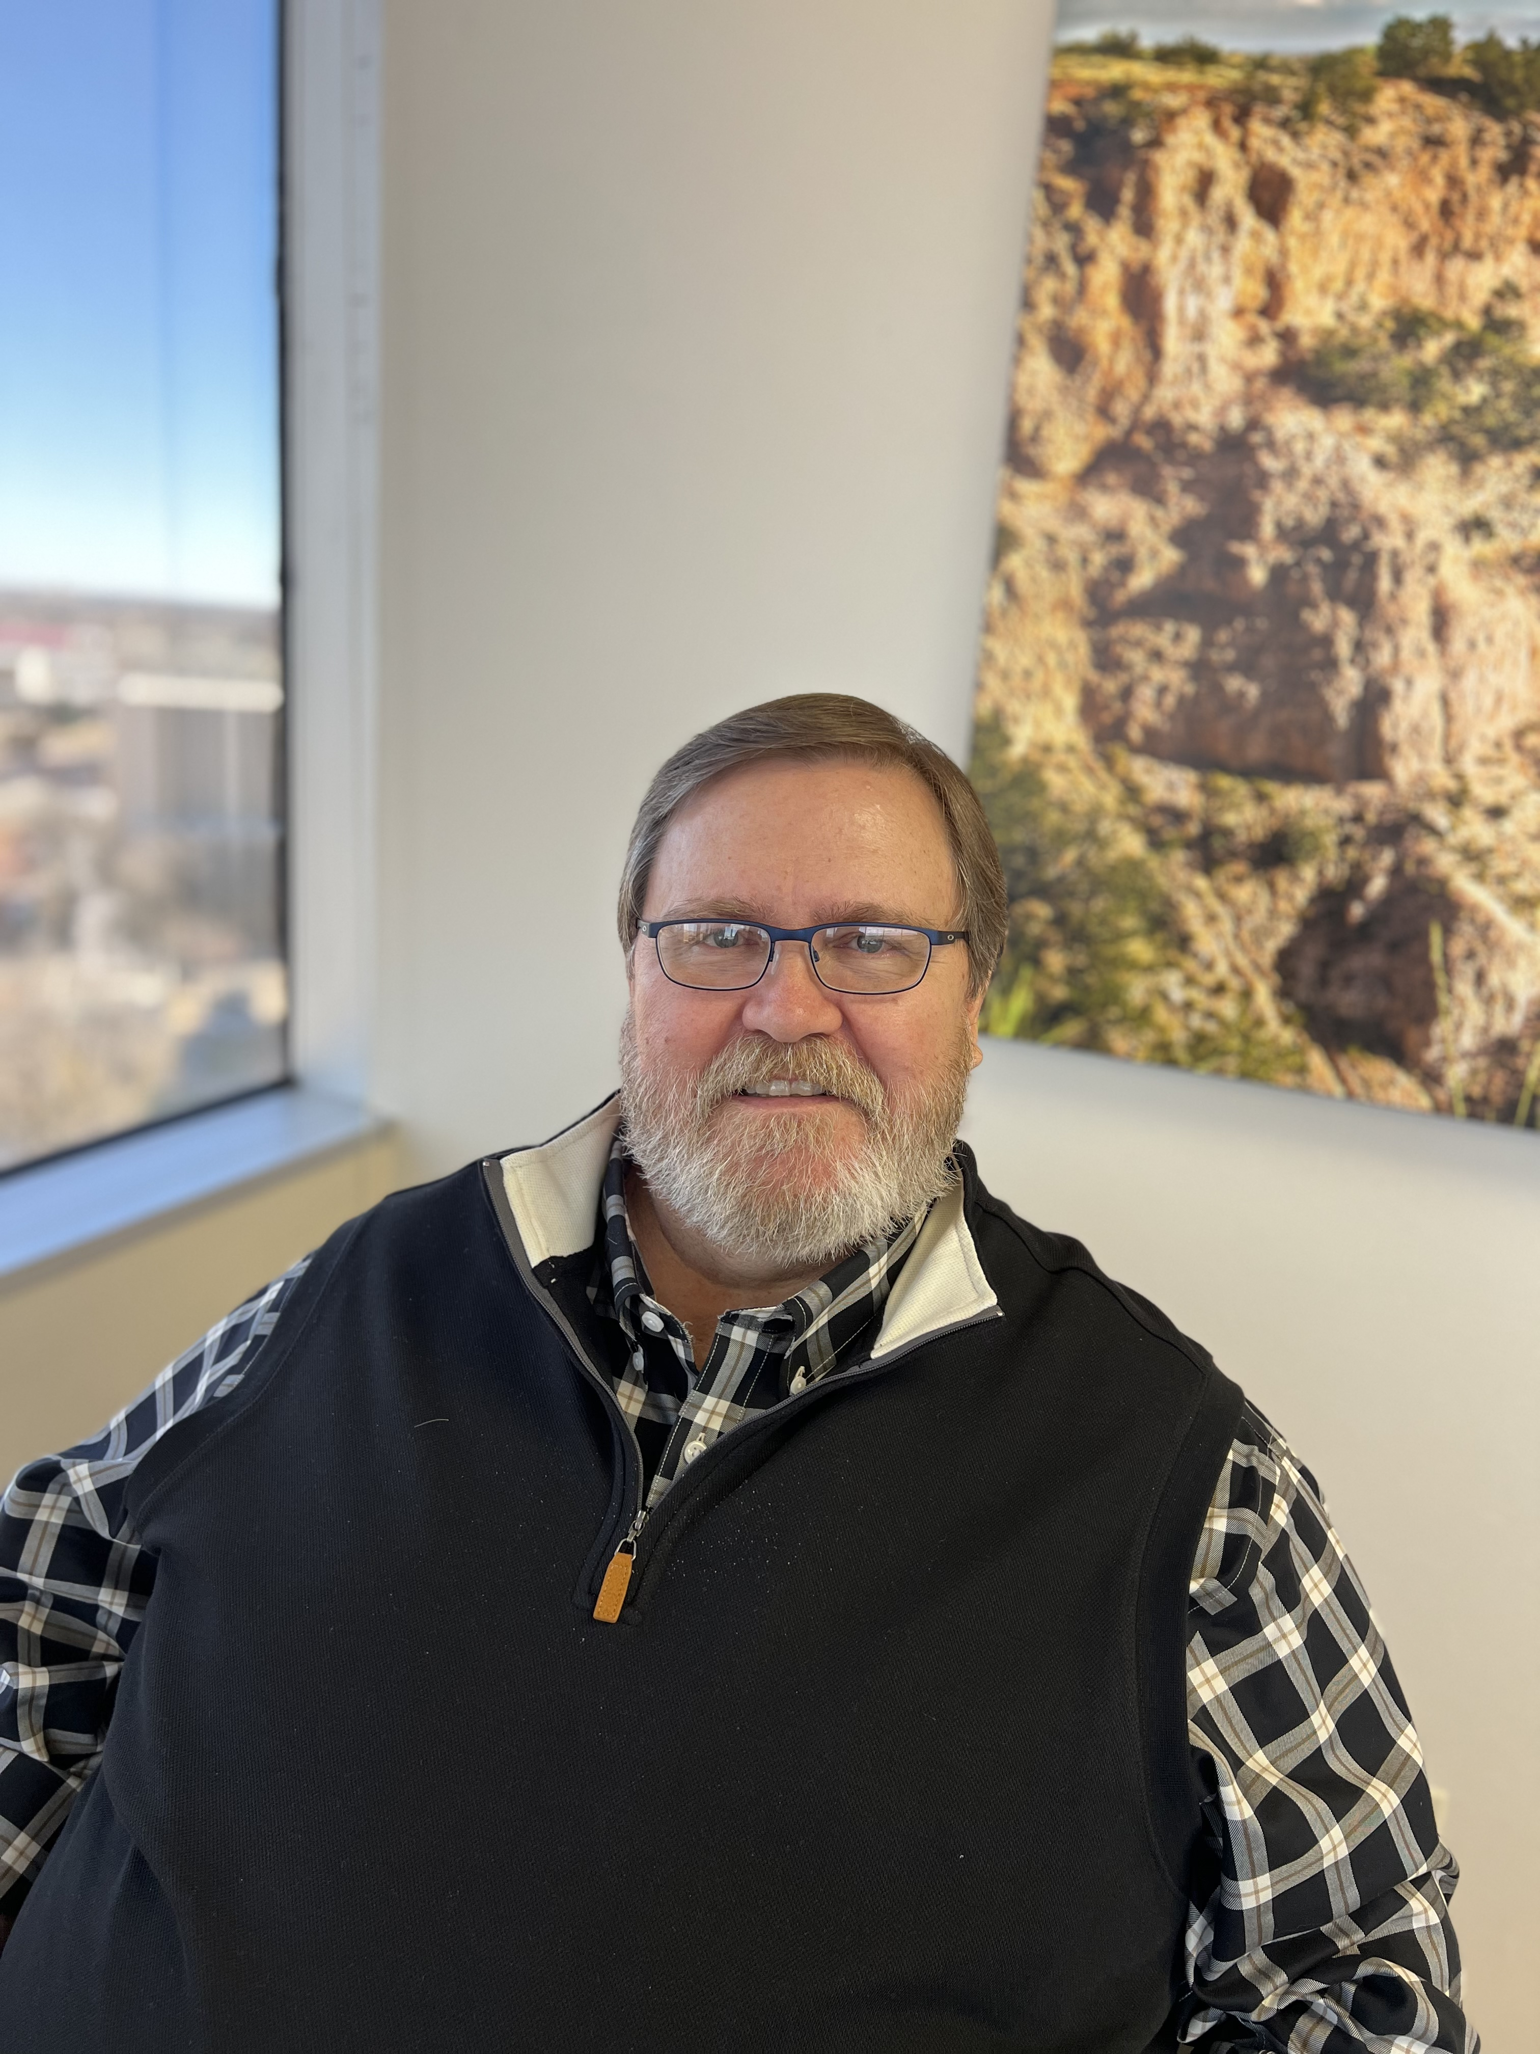

**“The Cancer Survivorship Center saved my life. I don’t think I’d be in remission right now if it weren’t for the Cancer Survivorship Center & the classes offered there.”**

Jack – Multiple Myeloma Survivor

Sincerely,