

Dear [NAME]:

Did you know that the American Cancer Society reports that 1 in 2 men and 1 in 3 women will likely develop cancer in their lifetime? Thanks to advancements in treatment, more people are beating their cancer and need help with the after effects.

On June 4th & 5th, I’m participating in the 16th Annual 24 Hours in the Canyon bike event. This event funds an adult Cancer Survivorship Center (www.24survivorship.org) that is FREE for patients to access, regardless of where they were treated, and from the moment of their diagnosis. This center is truly a one-of-a-kind. At the center, patients can visit with an oncology nurse about their cancer experience (Treatment Summary) and learn what to watch for in terms of side effects from the treatments they had (Care Plan). Survivors also have the ability to take advantage of the many Health & Wellness classes/events that are at the center. All of this is provided for FREE thanks to this event!

My goal is to fundraise $[AMOUNT] to help provide services at the Survivorship Center. I am asking you to make a tax-deductible donation so that cancer survivors will continue to get the care they need at no charge to them.

Enclosed you’ll find a donation form. If you feel led to help with my efforts, please fill it out & return it to the address listed. Also, please be sure to put my name in the blank asking for the name of the rider you are supporting. THANK YOU for helping me in my fundraising efforts, but more importantly, for helping survivors like Bill.

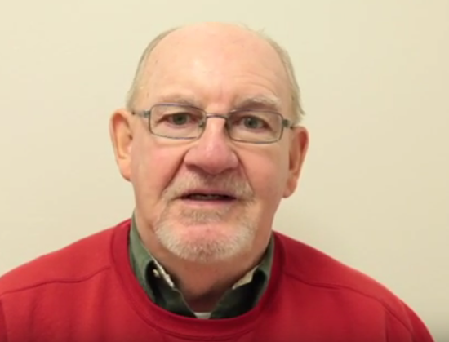

"Thank you for supporting the 24 Hours in the Canyon. Without the Cancer Survivorship Center, and the services it provides, I wouldn’t be here today.

THANK YOU!"

Bill – 2 Time Lung Cancer Survivor

Sincerely,